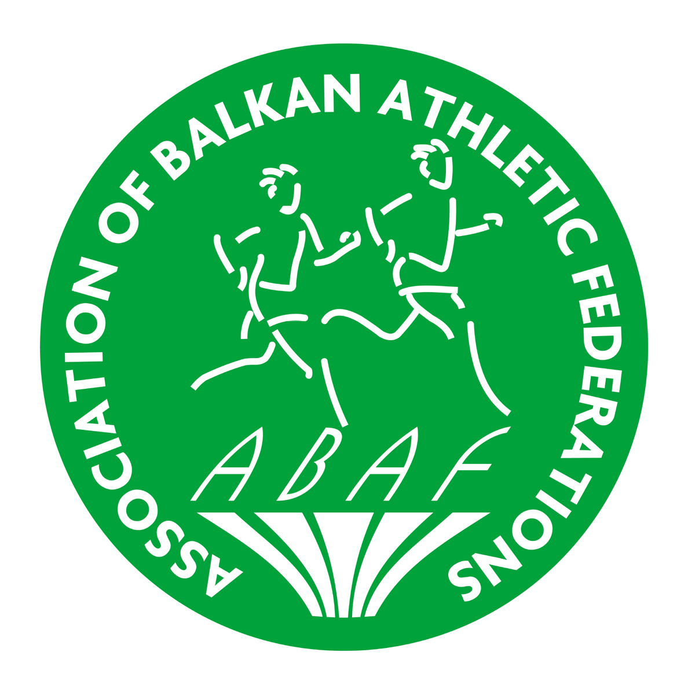 | 60th BALKAN  CROSS COUNTRY  CHAMPIONSHIPS  Ćuprija/SRB  November 5th, 2016 | 

PRELIMINARY ENTRY FORM

Country: _ ___

 | MEN | WOMEN | TOTAL

Team Leader

Head Coach

Official

Seniors
Seniors U23
Juniors
Coaches
Doctors
Physioterapists
Driver

TOTAL

Arrival |  |  | Departure
Date of arrival |  |  | Date of departure
Time fo arrival |  |  | Time of departure
Means of transport |  |  | Means of transport

This form must reach the AFS Office, not later than 26th September 2016
Athletic Federation of Serbia on e-mail:
office@serbia-athletics.org.rs

Name |  | Position
Signature |  | Date

